**Software Engineering Assignment**

**MODULE: 1**

**SE – Overview of IT Industry**

**What is software? What is software engineering?**

**What is software?**

**Ans:** Software refers to a collection of instructions or data that directs a computer's hardware to perform specific tasks or operations. It encompasses programs, applications, and scripts that enable computers and other digital devices to execute desired functions, ranging from simple calculations to complex processes. Software can be thought of as the intangible "brain" of a computer system, enabling users to interact with hardware and achieve their computing goals effectively.

For example like MS-Word, MS-Excel, PowerPoint, etc.

**What is software engineering?**

**Ans:** Software engineering is the systematic application of engineering principles, techniques, and methodologies to the design, development, deployment, and maintenance of software systems. It focuses on creating high-quality software products that are reliable, efficient, and scalable, while also considering factors such as usability, security, and maintainability. Key activities within software engineering include requirements analysis, software design, coding, testing, and ongoing maintenance, all aimed at delivering software solutions that meet the needs of users and stakeholders.

**Explain types of software**

**Ans:** There are several types of software, each serving different purposes and catering to various needs and functionalities. Here are the main types of software:

**1.System Software**

**2.Application Software**

**1.System Software**:

**Operating Systems**: Manage computer hardware and provide services for application software. Examples include Windows, macOS, Linux, and iOS.

**Device Drivers:** Control and communicate with peripheral devices such as printers, scanners, and graphics cards.

**Utilities**: Perform maintenance tasks like disk cleanup, data backup, and system optimization.

**2.Application Software:**

**Productivity Software**: Includes word processors (e.g., Microsoft Word, Google Docs), spreadsheets (e.g., Microsoft Excel, Google Sheets), and presentation software (e.g., Microsoft PowerPoint, Google Slides).

**Database Software:** Manages and organizes data, such as MySQL, Oracle, and Microsoft Access.

**Media Software:** Handles multimedia content, including media players (e.g., VLC, Windows Media Player), graphic design tools (e.g., Adobe Photoshop, GIMP), and video editing software (e.g., Adobe Premiere, Final Cut Pro).

**Communication Software:** Facilitates communication, such as email clients (e.g., Microsoft Outlook, Gmail), messaging apps (e.g., Skype, Slack), and internet browsers (e.g., Google Chrome, Mozilla Firefox).

**Entertainment Software:** Provides entertainment and leisure activities, including video games (e.g., Fortnite, Minecraft) and virtual reality experiences.

**What is SDLC? Explain each phase of SDLC**

**Ans:**

**Software Development Life Cycle (SDLC)**

The Software Development Life Cycle (SDLC) is a structured process that software development teams follow to design, develop, test, and deploy software applications.

**1.Planning**: Defining the scope of the project, determining objectives, and establishing the roadmap for development.

**2.Analysis**: Gathering requirements from stakeholders, identifying goals and constraints, and documenting detailed specifications.

**3.Design:** Creating a blueprint or architecture that outlines how the software will be structured and how different components will interact.

**4.Implementation**: Writing code based on design specifications, following coding standards, and integrating various modules and components.

**5.Testing**: Conducting tests to identify and fix defects or issues in the software. This includes unit testing (testing individual components), integration testing (testing combined components), system testing (testing the entire system), and acceptance testing (testing by end-users).

**6.Deployment:** Releasing the software to the production environment, configuring it for end-users, and ensuring it operates as expected.

**7.Maintenance:** Making modifications to the software after deployment, fixing bugs, adding new features, and optimizing performance based on user feedback and changing requirements.

**What is DFD? Create a DFD diagram on Flipkart**

**Ans:** DFD stands for Data Flow Diagram. It is a graphical representation of how data flows through a system or a process. DFDs are commonly used in software engineering and business analysis to visualize the flow of data within an information system.

**0 LEVEL DFD**

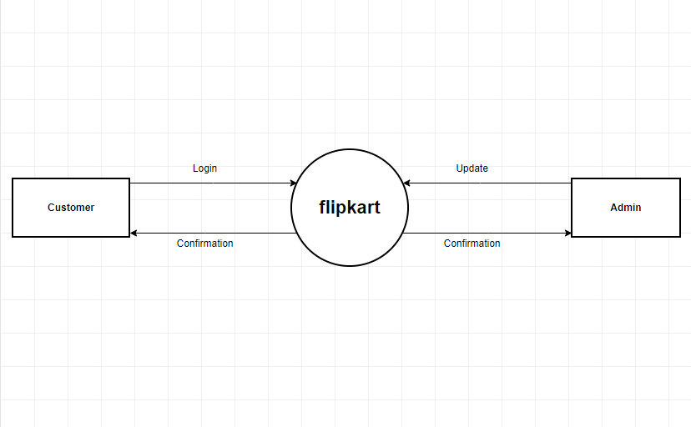

**1 LEVEL DFD**

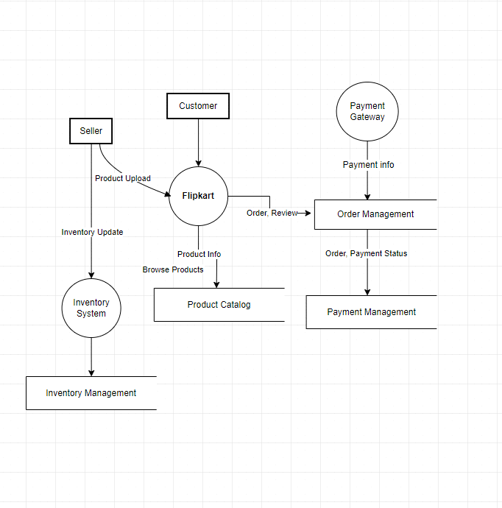

**2 LEVEL DFD**

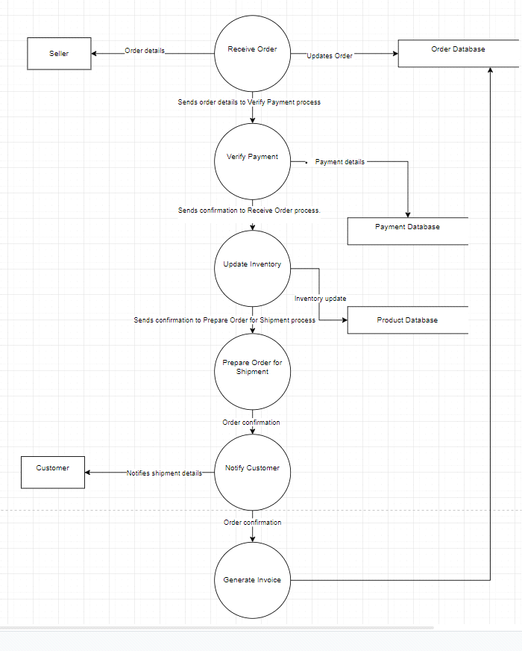

**What is Flow chart? Create a flowchart to make addition of two numbers**

**Ans:** A flowchart serves as a graphical depiction that illustrates the systematic progression of steps, decisions, or actions within a process or workflow. Utilizing standardized symbols and shapes, it visually represents the sequence involved, facilitating comprehension and analysis across diverse disciplines like software development, business process optimization, education, and engineering. Flowcharts are instrumental in outlining complex procedures, identifying critical decision points, and pinpointing potential efficiencies or bottlenecks. Their visual clarity aids in both the documentation and improvement of operational systems, making them an indispensable tool for process management and communication within organizations.

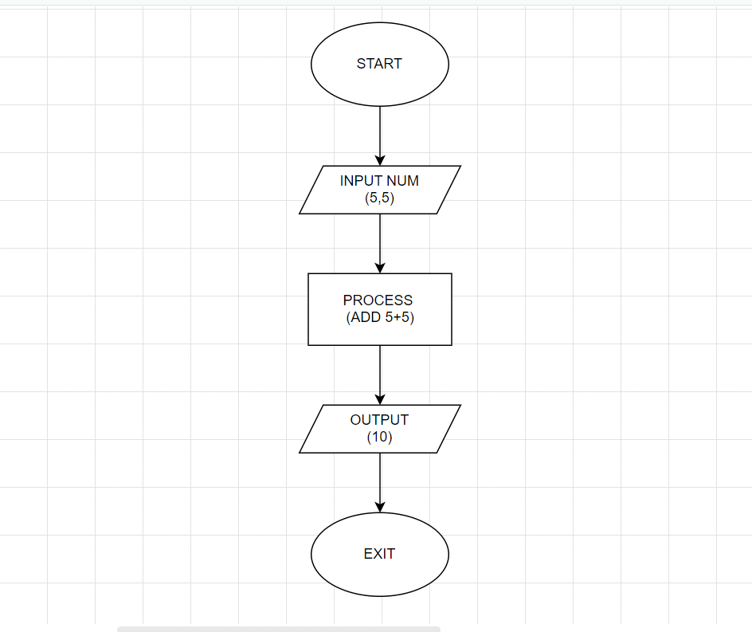

**What is Use case Diagram? Create a use-case on bill payment on paytm.**

**Ans:** A use case diagram is a graphical representation that depicts the interactions between actors (users or external systems) and a system under consideration to achieve specific goals. It's a part of the Unified Modeling Language (UML) and is commonly used in software development and systems engineering to visualize the functionality of a system.

